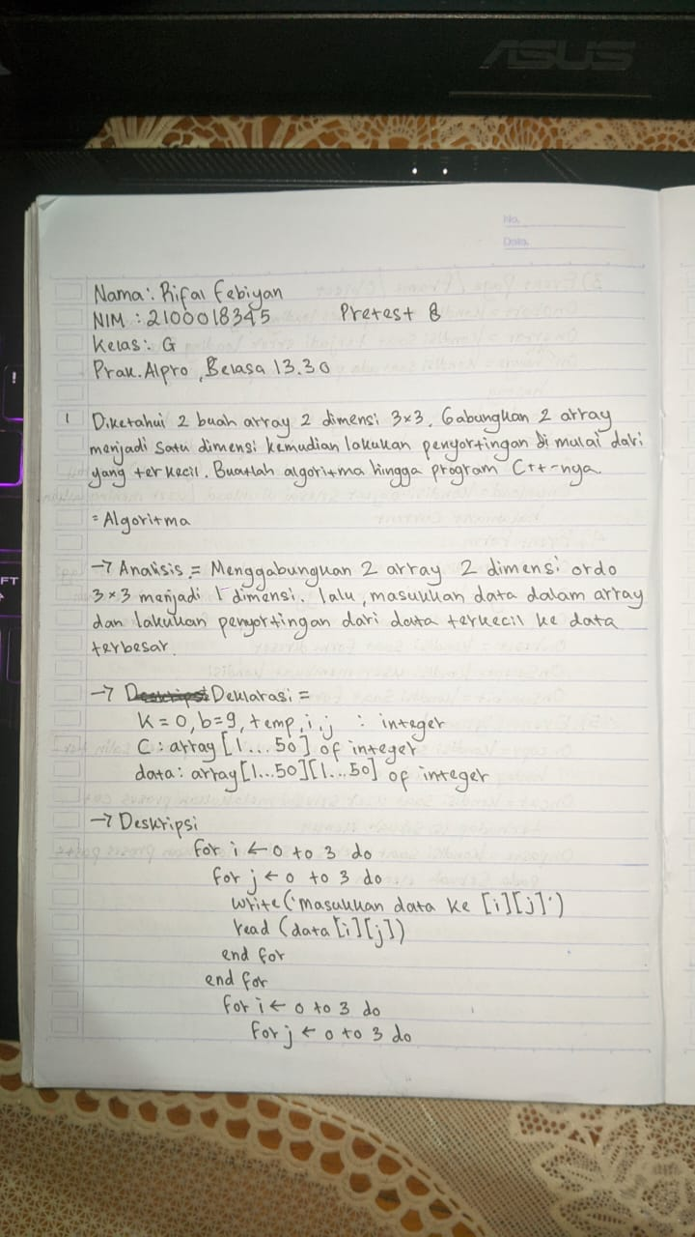

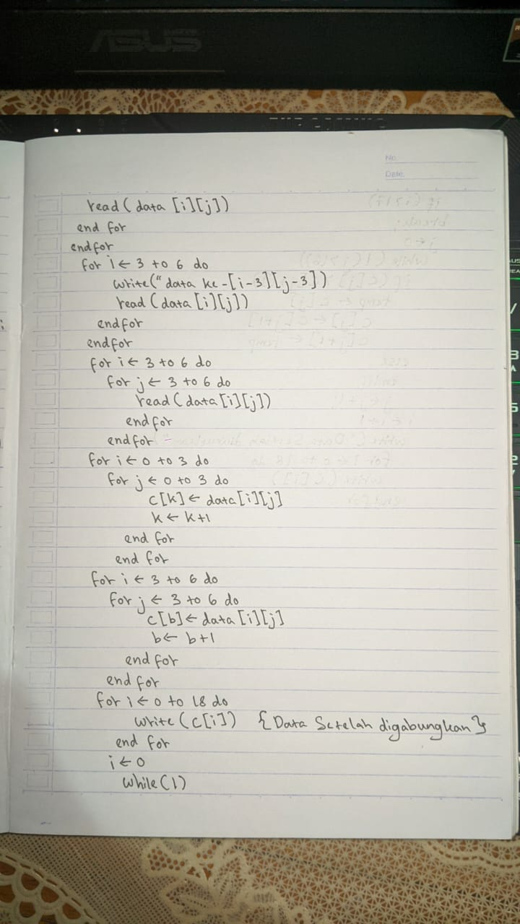

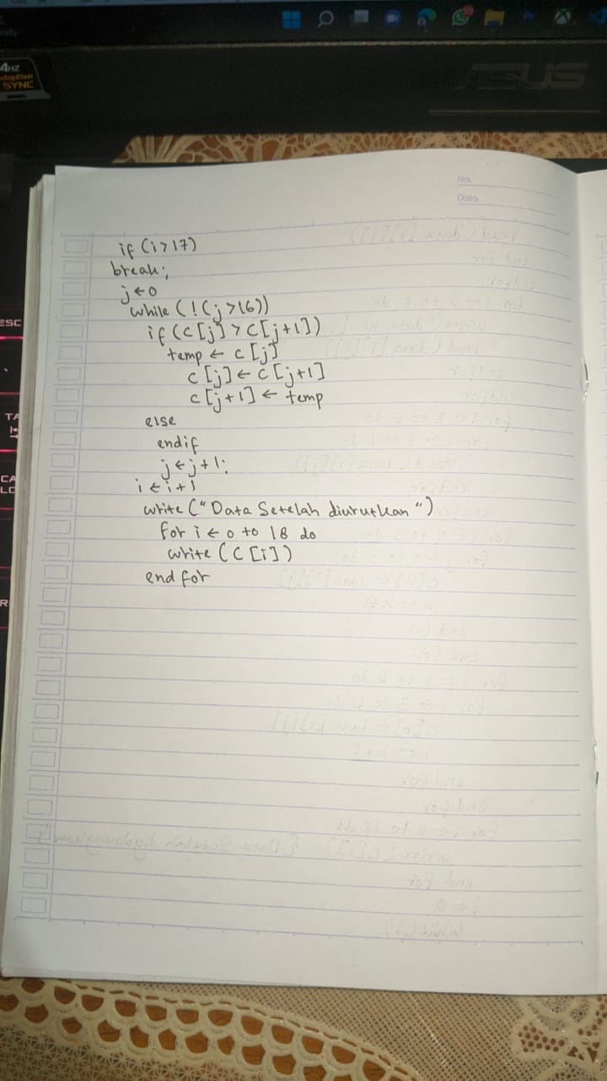

**PERCOBAAN 1 :**

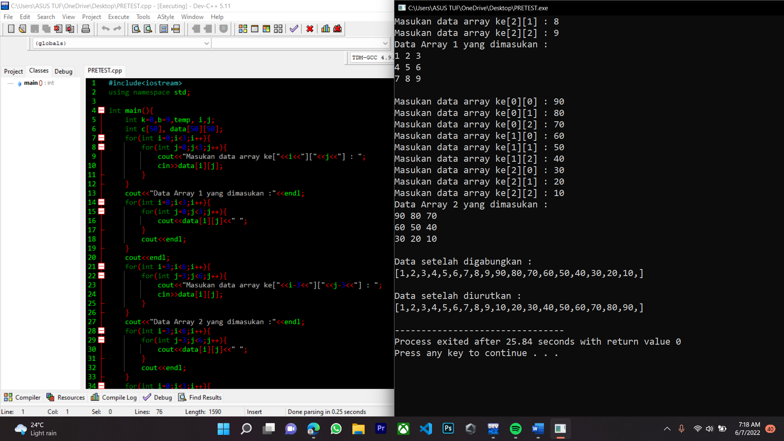

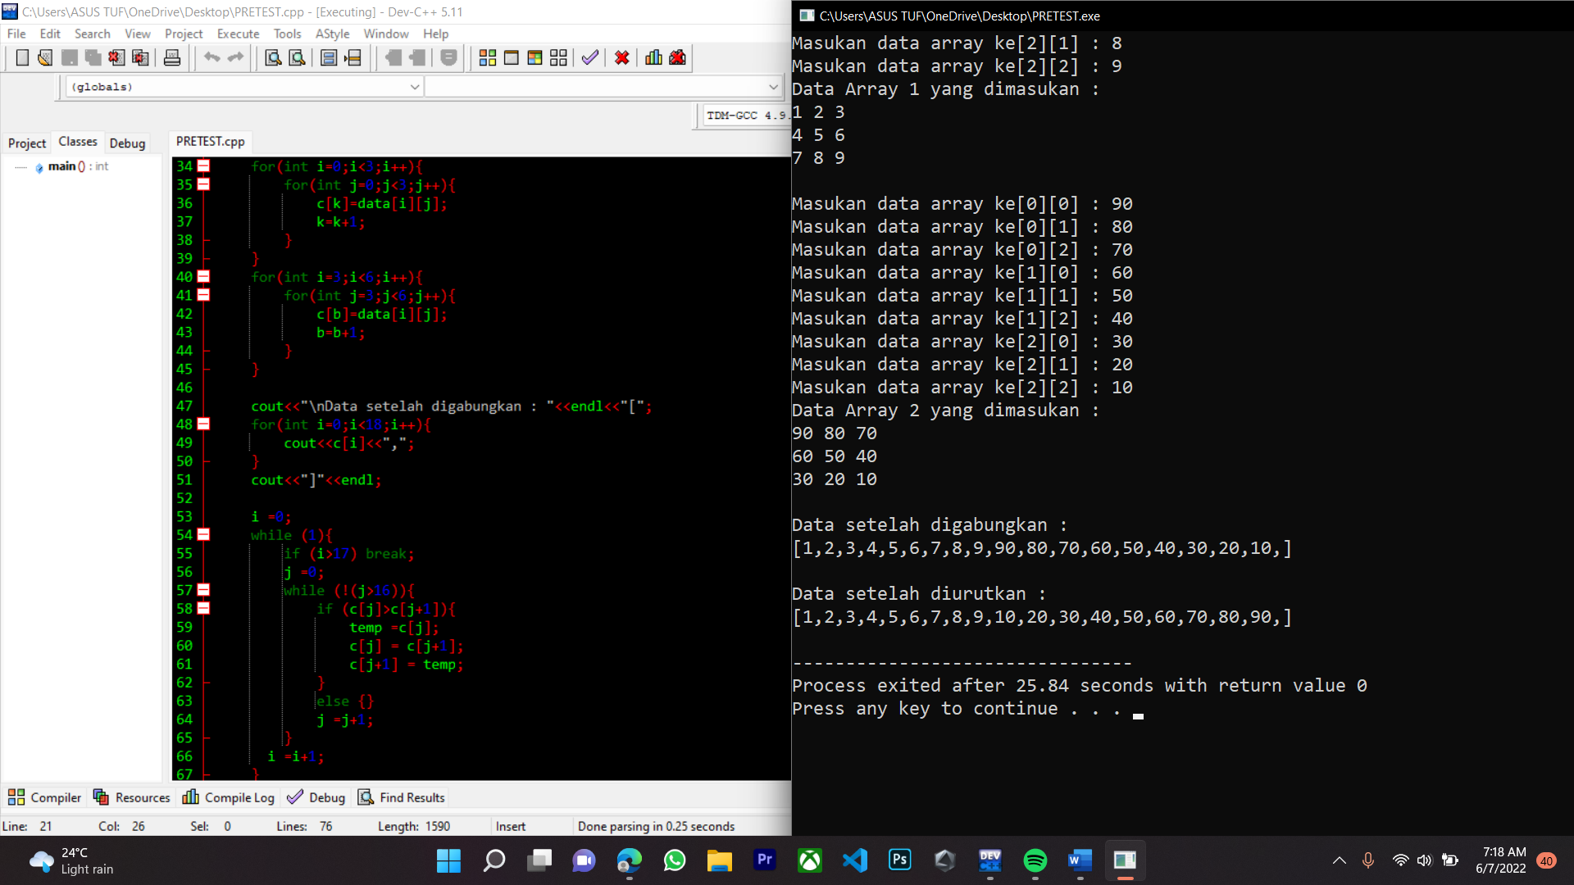

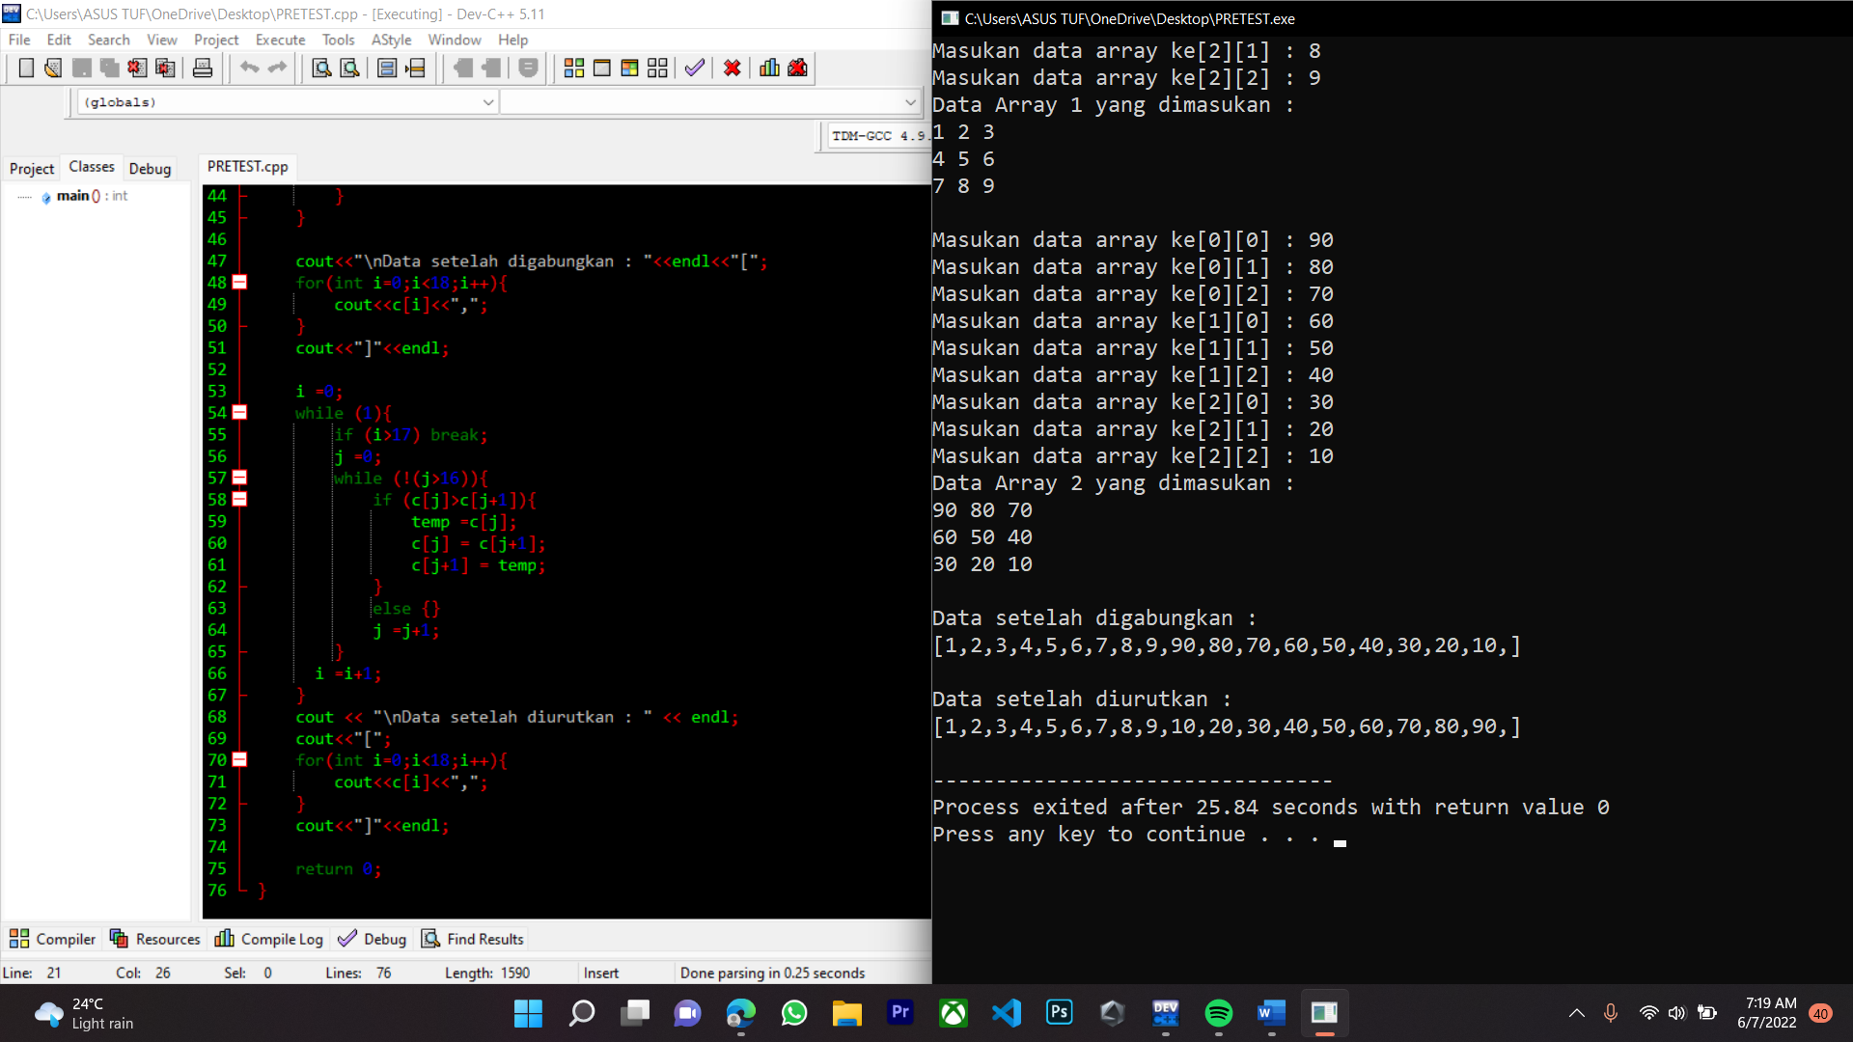

**PERCOBAA 2:**

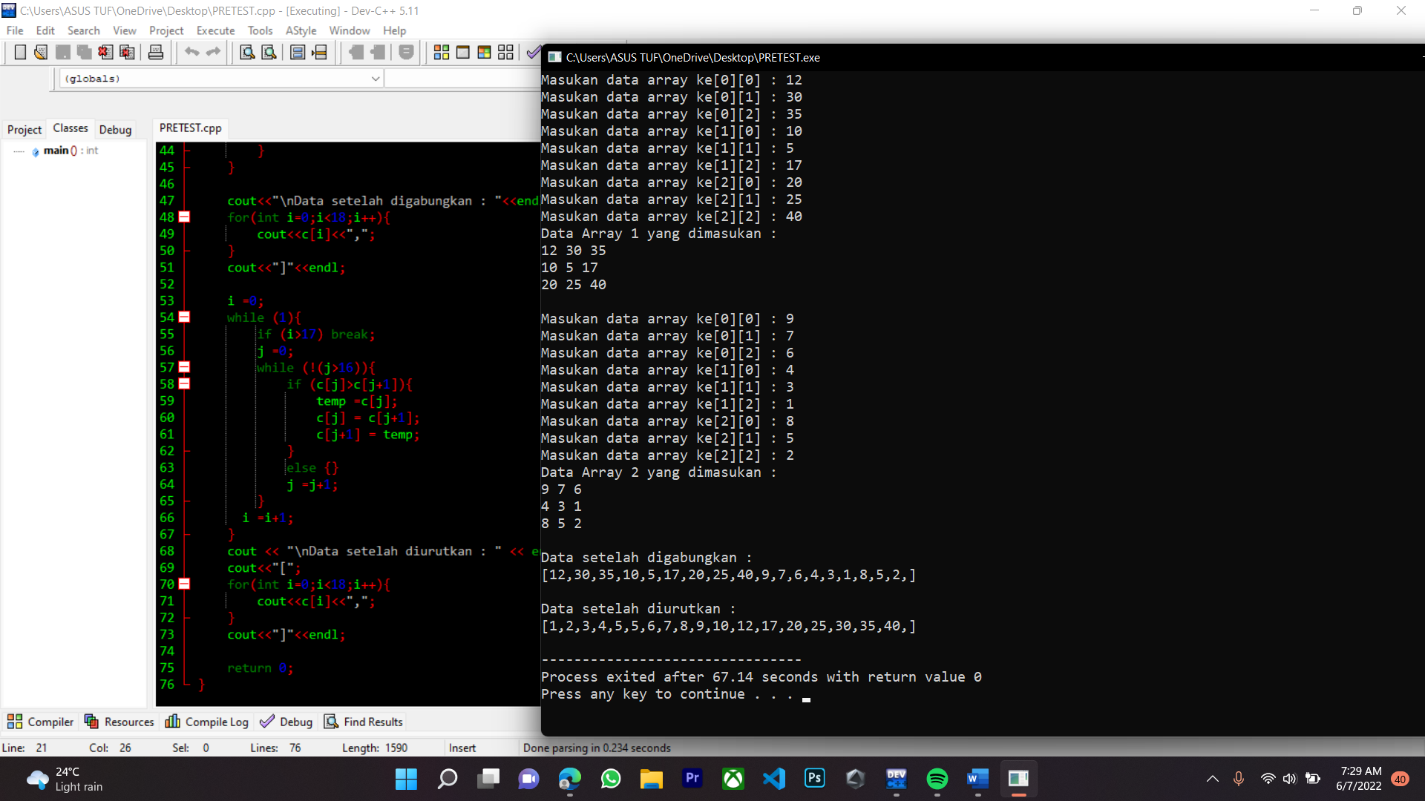

Source Code

|  |
| --- |
| #include<iostream>  using namespace std;  int main(){  int k=0,b=9,temp, i,j;  int c[50], data[50][50];  for(int i=0;i<3;i++){  for(int j=0;j<3;j++){  cout<<"Masukan data array ke["<<i<<"]["<<j<<"] : ";  cin>>data[i][j];  }  }  cout<<"Data Array 1 yang dimasukan :"<<endl;  for(int i=0;i<3;i++){  for(int j=0;j<3;j++){  cout<<data[i][j]<<" ";  }  cout<<endl;  }  cout<<endl;  for(int i=3;i<6;i++){  for(int j=3;j<6;j++){  cout<<"Masukan data array ke["<<i-3<<"]["<<j-3<<"] : ";  cin>>data[i][j];  }  }  cout<<"Data Array 2 yang dimasukan :"<<endl;  for(int i=3;i<6;i++){  for(int j=3;j<6;j++){  cout<<data[i][j]<<" ";  }  cout<<endl;  }  for(int i=0;i<3;i++){  for(int j=0;j<3;j++){  c[k]=data[i][j];  k=k+1;  }  }  for(int i=3;i<6;i++){  for(int j=3;j<6;j++){  c[b]=data[i][j];  b=b+1;  }  }    cout<<"\nData setelah digabungkan : "<<endl<<"[";  for(int i=0;i<18;i++){  cout<<c[i]<<",";  }  cout<<"]"<<endl;    i =0;  while (1){  if (i>17) break;  j =0;  while (!(j>16)){  if (c[j]>c[j+1]){  temp =c[j];  c[j] = c[j+1];  c[j+1] = temp;  }  else {}  j =j+1;  }  i =i+1;  }  cout << "\nData setelah diurutkan : " << endl;  cout<<"[";  for(int i=0;i<18;i++){  cout<<c[i]<<",";  }  cout<<"]"<<endl;    return 0;  } |